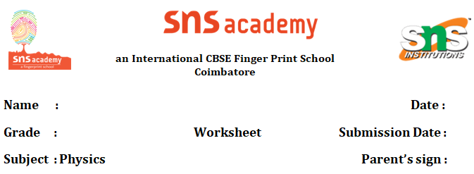

**Measurement and motion**

1. We measure the length of a room using the unit

a) km b) m c) both a and b d) none of these

1. Which of the following is not a 20th century contribution?

a) electric train b) motorised boat c) monorail d) supersonic aeroplanes

1. The unit used to measure the thickness of a coin is

a) km b) cm c) mm d) m

1. Write two examples for each of the following:
2. Rectilinear motion
3. Periodic motion
4. Your school admits children who live within 6 km from the school. Your friend Ayush lives 3000m from the school wants to go to the same school. Do you think he will get admission in your school?
5. Convert the following:

i) The distance between Delhi and Chennai is 2100 km . Convert the distance in metre.

iii) Time you spend in school is 6 hours. Convert it into seconds.

iii) The thickness of your science book is 13mm. Convert it into metre.

1. **HOTS**

A dozen of identical books are stacked one above the other to a height of 48cm.If 3 more books are added to the stack, then what will become the height of the stack ?

1. Trains A and B are running parallel to each other at equal speed. State whether a person in train A will be a state of rest or motion with respect to :
2. another person in train A
3. a person in train B
4. a bridge over which the train is running.